

Project Id: 2024MP_CSEPID011
Mini Project Synopsis
on
PrayasAI Disha
AI-Powered Personalized Internship Recommendation and Skill Gap Analysis System
Submitted in Partial Fulfillment of the Requirement
For the Degree of
Bachelor of Technology
In
Computer Science and Engineering
By
Kartikeya Verma (2402900100149)
Keshav Mittal (2402900100152)
Kartik Singhal (2402900100147)
Khushi Bhati (2402900100153)
Under the Supervision of
Mr Satyendra Singh
Assistant Professor
Department of Computer Science Engineering
ABES INSTITUTE OF TECHNOLOGY, GHAZIABAD
AFFILIATED TO

Dr. A.P.J. ABDUL KALAM TECHNICAL UNIVERSITY, UTTAR PRADESH, LUCKNOW
(ODD SEM, 2026-27)

Table of Contents
Chapter No. | Contents | Page No.
1 | Abstract | 3
2 | Introduction | 4
3 | Literature Survey | 6-7
4 | Problem Statement | 8
5 | Proposed Methodology | 9-14
6 | Implementation & Results | 15-16
7 | Mapping with SDG Goal | 17
8 | Conclusion/Future Scope | 18
9 | References | 19

1. Abstract
Students searching for internships often face a large number of opportunities with different domains, eligibility conditions, locations, descriptions, and skill requirements. Manual comparison of these opportunities with an individual student's academic background, skills, interests, and preferences can be time-consuming and may not consistently identify the most relevant options. PrayasAI Disha is proposed as a web-based AI-powered personalized internship recommendation and skill gap analysis system developed in the context of the AI-based internship recommendation problem represented by SIH problem statement SIH25034. The system analyzes student-profile information and internship-related information to determine compatibility. Natural Language Processing techniques are used to represent suitable textual attributes through Term Frequency–Inverse Document Frequency (TF-IDF), while cosine similarity provides a measure of textual/profile similarity. A weighted recommendation approach can combine relevant matching factors such as skill similarity, academic or branch relevance, interest matching, and internship requirement compatibility. The system also performs skill-gap analysis by comparing a student's existing skills with the skills required by relevant internship opportunities. The proposed web architecture uses React.js and Tailwind CSS for the frontend, Flask REST APIs for the backend, and MySQL for persistent data storage. The project is intended as an academic prototype and is currently under development; therefore, final accuracy, performance, deployment, and real-world impact are not claimed.
Keywords: Internship Recommendation, Skill Gap Analysis, Natural Language Processing, TF-IDF, Cosine Similarity, Personalized Recommendation.

2. Introduction
Internships provide students with opportunities to gain practical exposure, understand workplace expectations, and connect academic learning with professional skills. However, the process of finding an appropriate internship can become difficult when students are presented with many opportunities that vary in domain, organization, location, eligibility, required skills, and role description. The challenge is not only to locate internship listings, but also to determine which opportunities are relevant to an individual student's current profile and future interests.
A common approach to internship discovery is manual searching through job or internship portals, followed by reading individual descriptions and comparing them with personal skills and eligibility. This process requires repeated effort and may make it difficult for a student to identify the most suitable opportunities efficiently. The problem becomes more significant when internship descriptions contain unstructured text and when the same skill may be expressed using different words or phrases.
Recommendation systems provide a computational approach for reducing information overload by filtering and presenting items that are more relevant to a user's profile. In an internship setting, the items are internship opportunities, while the user profile may contain academic background, branch, skills, interests, and preferences. Content-based techniques are particularly relevant because they can compare characteristics of a user's profile with textual or structured attributes of available opportunities. Recent literature on internship and job recommendation systems discusses content-based filtering, collaborative filtering, hybrid approaches, similarity measures, and skill-oriented matching.
Natural Language Processing (NLP) can be used to process textual information such as skill descriptions and internship requirements. TF-IDF is a classical and interpretable method for representing the importance of terms in documents. After transforming profile and internship text into numerical vectors, cosine similarity can be used to estimate how closely the two representations are aligned. These techniques are suitable for an academic prototype because they provide a transparent baseline for text-based matching without requiring a large deep-learning training pipeline.
In addition to textual similarity, internship recommendation may require consideration of other profile-related factors such as academic branch, skills, interests, and internship requirements. A weighted recommendation approach can therefore combine relevant matching factors to determine the compatibility between a student profile and available internship opportunities. The exact contribution of individual factors can be finalized through implementation and testing.
In addition to recommendation, a useful internship-support system should help a student understand why an opportunity may or may not fit the current profile. Skill-gap analysis addresses this requirement by comparing the student's known skills with the skills required by relevant internship opportunities. The output can distinguish matched skills from missing or improvement-oriented skills. Such information can help a student understand the requirements of a target internship rather than simply receiving a list of opportunities.
PrayasAI Disha is proposed in this context as an AI-powered personalized internship recommendation and skill gap analysis system. The project is inspired by the PM Internship Scheme problem domain and the SIH problem statement SIH25034. It is important to clarify that PrayasAI Disha is a student-developed academic prototype and is not being presented as an official Government of India application, an adopted Ministry of Corporate Affairs platform, or an officially integrated component of the PM Internship portal.
The proposed system follows a layered web architecture. A React.js and Tailwind CSS frontend collects and displays information for the user. A Flask-based backend exposes REST APIs and coordinates communication between the frontend, database, and recommendation components. MySQL is used for persistent storage. The recommendation engine performs preprocessing, feature extraction, similarity calculation, weighted matching, and skill-gap analysis before producing recommendation results for presentation through the web interface.
The frontend provides the primary interaction layer of the system. It is responsible for collecting relevant student information and presenting internship recommendations and skill-gap results in an understandable format. The frontend communicates with the backend through REST APIs rather than directly accessing the database. This separation helps maintain a structured architecture in which the user interface, application logic, recommendation processing, and data storage perform separate functions.
The overall processing flow begins with student profile and internship information. The data is processed and suitable textual attributes are converted into TF-IDF representations. Cosine similarity is then used to compare the profile and internship representations. Relevant compatibility factors can be combined through weighted matching, followed by skill-gap analysis. The resulting recommendation information is returned through the backend and presented to the student through the frontend.
The project therefore combines software engineering, database management, web development, information retrieval, and basic machine-learning/NLP techniques into a single academic system. The current development work includes the Flask backend, MySQL connectivity and database setup, React frontend development, and recommendation-module development. Components that require final data acquisition, comprehensive testing, performance evaluation, or deployment remain under development and are treated as proposed or future work rather than completed outcomes.
The system is designed with a focus on personalization and clarity so that students can obtain recommendations that are relevant to their individual profiles. By combining profile information, internship requirements, similarity-based matching, and skill-gap analysis, PrayasAI Disha aims to provide a more structured way of exploring internship opportunities. The system also maintains a clear separation between the user interface and backend processing, allowing the frontend to present recommendation results while the underlying processing is handled by the backend components. This approach provides a foundation for further enhancement of the system through improved datasets, testing, evaluation, and additional recommendation features.

3. Literature Survey
The literature survey focuses on research related to job and internship recommendation, profile-to-opportunity matching, NLP-based recommendation, and skill-oriented career support. The selected works were verified against publisher or academic-index pages and were chosen because their methods or findings are directly relevant to the design of PrayasAI Disha.
S. No. | Author(s) & Year | Title of Paper / Work | Objective / Focus | Methodology / Approach | Key Findings
1 | Poncio (2024) | Navigating techniques in job recommender systems on internship profile matching: A systematic review | Reviews methods used for internship/job recommender systems, profile evaluation, and suggestion/ranking. | Systematic review of data collection, filtering techniques, similarity/ranking approaches, and evaluation methods. | Reports that primary profile data can improve personalization and that hybrid approaches can mitigate limitations of individual filtering methods.
2 | Kumar, Gupta, Sharma, & Ofori (2022) | Technical Job Recommendation System Using APIs and Web Crawling | Automate collection and recommendation of technical job opportunities. | Web crawling and APIs; hybrid content-based and collaborative filtering; TF-IDF and cosine similarity are used within the matching process. | Demonstrates a web-based job recommendation workflow and emphasizes reducing the burden of manually searching numerous technical job sources.
3 | Alsaif, Sassi Hidri, Eleraky, Ferjani, & Amami (2022) | Learning-Based Matched Representation System for Job Recommendation | Recommend jobs by matching job-seeker skills with job-listing features. | Content-based filtering and NLP-based matching of resume/profile information with job listings; evaluation of recommendation performance. | Shows the usefulness of skill-oriented matching and a web-based recommendation design for handling large numbers of job listings.
4 | Rajput, Dubey, Thakur, Singh, & Singh (2024) | Career Craft AI: A Personalized Resume Analysis and Job Recommendations System | Combine resume/profile analysis with personalized job recommendation and career support. | NLP, profile classification, cosine similarity, and recommendation using skills and profile information. | Illustrates how profile analysis and similarity-based recommendation can be combined to provide personalized job suggestions and supporting insights.
5 | Almalki, Al-Alsheikh, Bahareth, Abdullah, & Alsahafi (2025) | BERT-based Job Recommendation System Using LinkedIn Dataset | Improve semantic understanding of job descriptions and user profiles for personalized recommendation. | BERT-based contextual NLP with content-based recommendation using skills and preferences. | Explores contextual semantic matching as an alternative to traditional keyword-oriented methods, highlighting the potential of transformer-based representations.

3.1 Literature Gap
The reviewed literature shows that recommendation systems can reduce information overload by matching user profiles with job or internship descriptions. Content-based methods provide an interpretable baseline through textual similarity, while hybrid and semantic approaches can address limitations of simple keyword matching. The literature also shows that internship-specific recommendation remains a distinct application context in which student goals, academic background, skills, and opportunity requirements need to be considered together. Although job recommendation systems have been widely studied, internship recommendation has additional requirements because students may have limited professional experience and their academic qualifications, technical skills, interests, and eligibility conditions can play an important role in determining suitable opportunities.
Existing approaches also demonstrate the usefulness of Natural Language Processing techniques for handling unstructured job and internship descriptions. Methods such as TF-IDF can represent important terms from textual information, while similarity measures such as cosine similarity can be used to compare a student's profile with the requirements of an opportunity. However, simple textual similarity alone may not capture every aspect of internship suitability. Factors such as academic branch, relevant skills, interests, eligibility, and other opportunity-related attributes may also need to be considered. This creates a need for a matching approach that can combine textual similarity with additional profile-based factors.
PrayasAI Disha uses this research direction as a practical academic baseline. Instead of depending on a complex deep-learning training pipeline, the proposed system uses TF-IDF and cosine similarity together with conceptually weighted matching factors. The approach allows student and internship information to be processed in a structured manner before generating recommendations. The use of interpretable techniques also makes the recommendation process easier to understand and suitable for an academic prototype where the availability of a large, validated training dataset may be limited.
Another important gap addressed by the proposed system is the limited focus on skill-gap identification alongside internship recommendation. A recommendation system that only provides a list of internships may not clearly indicate why a particular opportunity is relevant or what the student needs to improve. PrayasAI Disha therefore adds an explicit skill-gap analysis stage that compares the student's available skills with the skills required by relevant internship opportunities. The resulting output can identify matched skills as well as missing or improvement-oriented skills, providing additional information that can support the student's preparation for future opportunities.
The proposed system also addresses the need for an integrated web-based implementation. Rather than treating recommendation as an isolated algorithm, PrayasAI Disha combines the recommendation process with a React.js and Tailwind CSS frontend, Flask-based REST APIs, and MySQL-based data storage. This allows student information to be collected through the frontend, processed through the backend and recommendation components, and returned as understandable recommendation and skill-gap results. The separation of these components provides a structured foundation for further development and evaluation.

4. Problem Statement

4.1 Description of the Problem Statement
Students often find it difficult to identify internship opportunities that align with their existing skills, academic background, interests, and preferences. At the same time, internship opportunities contain their own eligibility criteria, required skills, domains, descriptions, and other requirements. Manually comparing these two sides across a large collection of opportunities is time-consuming and may not provide a consistent method for identifying relevant options.
Therefore, there is a need for a web-based system that can analyze student-profile information and internship requirements, measure their compatibility, provide personalized internship recommendations, and identify skill gaps between the student's current capabilities and the requirements of relevant opportunities. PrayasAI Disha addresses this problem as an academic prototype in the context of SIH problem statement SIH25034 and the PM Internship Scheme problem domain.

4.2 Objectives
- To develop a web-based personalized internship recommendation system for students.
- To analyze student profiles and internship requirements using structured and textual information.
- To apply TF-IDF and cosine similarity for relevant text-based profile and internship matching.
- To combine relevant compatibility factors through a weighted recommendation approach without assuming fixed weights until they are experimentally finalized.
- To identify skill gaps by comparing student skills with the skills required by relevant internship opportunities.
- To present internship recommendations and skill-gap information through a user-friendly web interface.
- To implement the system using React.js, Tailwind CSS, Python, Flask, Pandas, scikit-learn, and MySQL.
- To establish a scalable academic foundation for future enhancements such as improved semantic matching, validated live data integration, and feedback-based personalization.

5. Proposed Methodology

5.1 System Overview
The proposed PrayasAI Disha system follows a layered architecture in which the frontend collects and presents user information, the Flask backend coordinates application logic, the recommendation engine performs matching and skill-gap analysis, and the MySQL database stores structured information. The conceptual processing flow is: Student Profile → Data Processing → Feature Extraction → Similarity Calculation → Weighted Matching → Skill Gap Analysis → Recommendation → User Interface.

5.2 Technology Stack
Layer | Technology | Purpose
Frontend | React.js, Tailwind CSS, JavaScript, HTML5 | Responsive user interface, profile forms, internship display, and result presentation.
Backend | Python, Flask, Flask REST APIs | Application logic, API endpoints, validation, and coordination between modules.
Database | MySQL | Persistent storage for student, internship, and related structured information.
AI/ML | Python, Pandas, scikit-learn | Data preparation, feature processing, similarity computation, and recommendation logic.
Recommendation | TF-IDF, Cosine Similarity, Weighted Recommendation | Text representation, similarity measurement, and combined compatibility scoring.

5.3 System Architecture
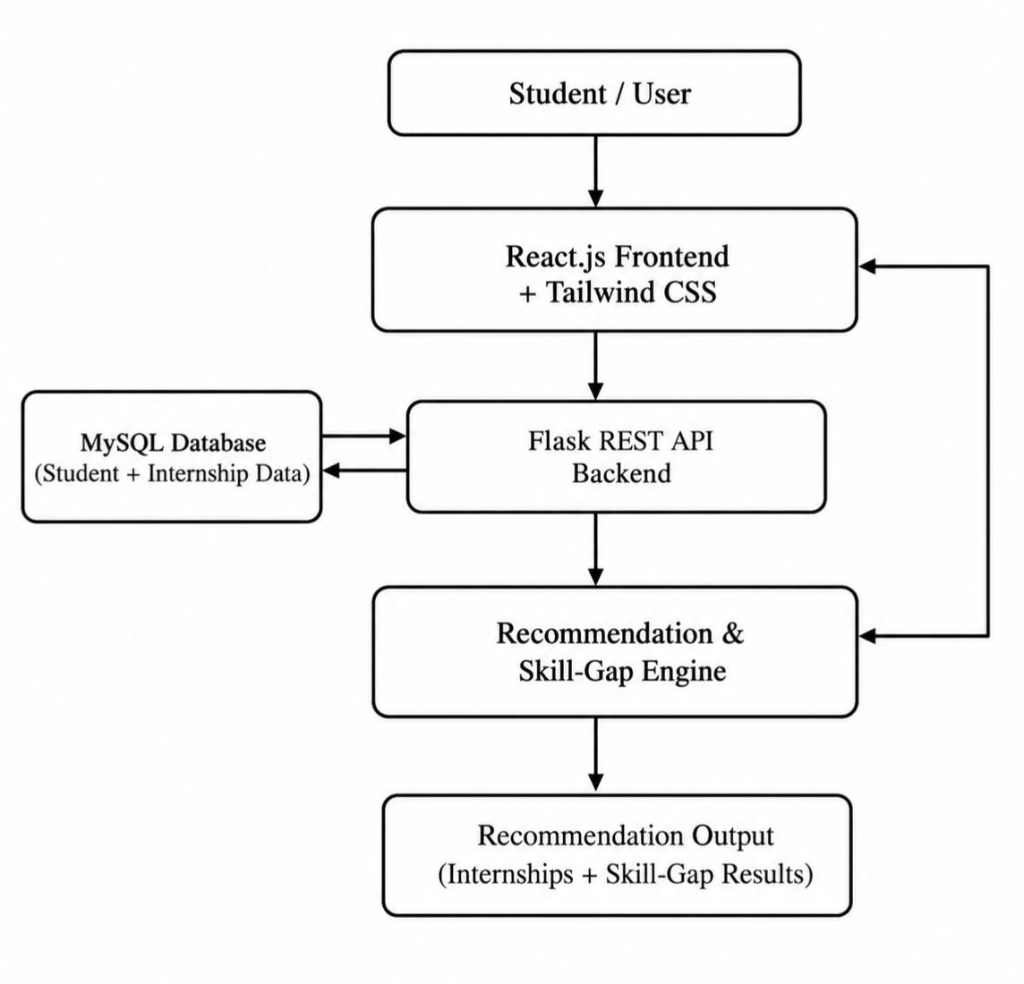
The architecture deliberately places MySQL behind the Flask backend. The React frontend communicates with Flask REST APIs rather than connecting directly to the database. The recommendation and skill-gap engine is invoked through backend application logic and uses processed student and internship information.
The React.js frontend with Tailwind CSS provides the user-facing interface of the system. It is responsible for collecting student information and presenting internship recommendations and skill-gap results in a structured and user-friendly manner. The frontend sends the required information to the backend through REST API requests and receives the processed results for display.
The Flask REST API backend acts as the central communication layer between the frontend, database, and recommendation components. It handles incoming requests from the frontend, processes the required data, and coordinates the execution of the recommendation and skill-gap analysis modules. This separation ensures that database operations and application logic are not directly exposed to the frontend.
The MySQL database is used for persistent storage of student and internship-related information. It can store details such as student profiles, academic information, skills, interests, and available internship attributes. The backend communicates with the database whenever information needs to be stored, retrieved, or processed for recommendation generation.
The Recommendation and Skill-Gap Engine processes the required student and internship information to determine relevant opportunities. The recommendation process includes data preprocessing, feature extraction, similarity calculation, and weighted matching. The skill-gap component compares the student's available skills with the requirements of relevant internships to identify matched and missing skills.
.

5.4 Data Flow
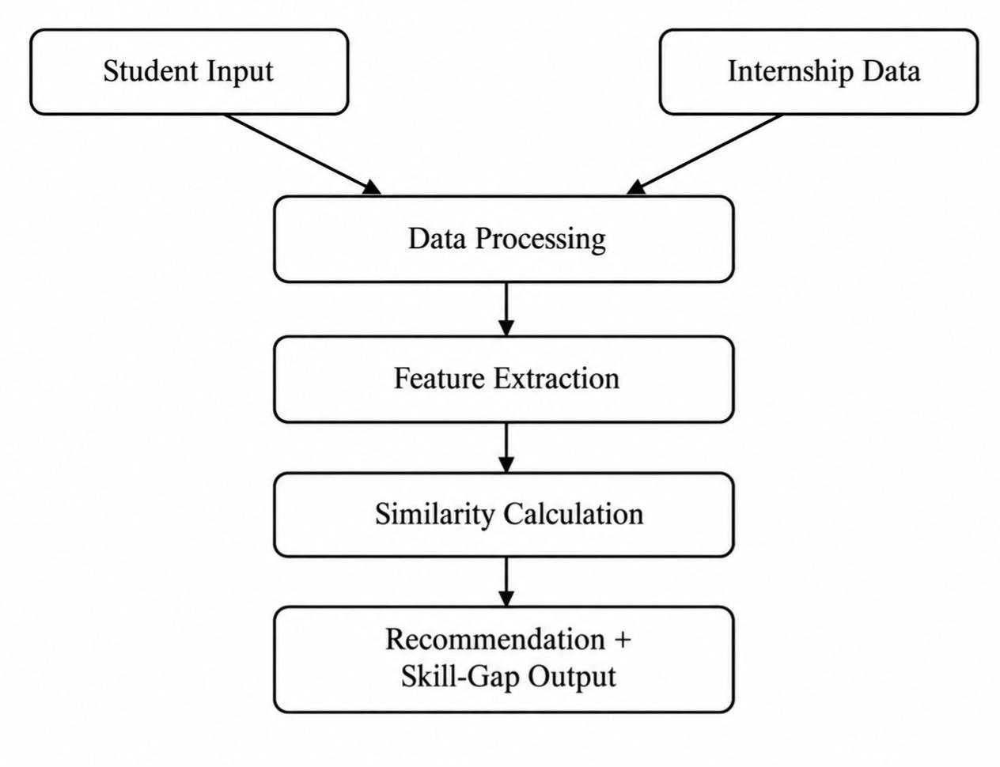
The system receives student information and internship-related information as inputs. Student information may include academic details, skills, interests, and other relevant profile attributes, while internship information contains details such as required skills, eligibility, domain, and other opportunity-related attributes.
The input data is first passed through data processing, where the information is cleaned, prepared, and normalized for further processing. Relevant features are then extracted from the processed student and internship data. These features are used by the matching process to determine the similarity and relevance between the student profile and available internship opportunities.
After feature extraction, the system performs similarity calculation and matching to identify suitable internship opportunities. The matching process considers relevant profile and internship attributes to generate personalized recommendations. The system also performs skill-gap analysis to identify skills that are already matched and skills that may require improvement.
Finally, the processed results are provided as recommendation and skill-gap output. These results are returned through the backend to the frontend, where they are presented to the student in a structured and understandable manner. Thus, the data flow connects the initial student and internship inputs with data processing, feature extraction, matching, and the final recommendation output.

5.5 Recommendation Methodology
Stage 1 — Student Profile: The student provides relevant information such as branch or discipline, skills, interests, preferences, and academic information. Only information required by the implemented application should be collected.
Stage 2 — Internship Data: Relevant internship information is represented using attributes such as internship title, organization, sector/domain, location, eligibility, required skills, description, and other available requirements. The final data-acquisition method is dependent on the validated source and implementation status.
Stage 3 — Data Preprocessing: Textual fields are cleaned and normalized so that profile and internship descriptions can be compared more consistently. Appropriate preprocessing may include case normalization, whitespace handling, removal of irrelevant tokens, and preparation of skill phrases.
Stage 4 — Feature Extraction: TF-IDF converts suitable textual information into numerical vectors. The technique assigns higher importance to terms that are informative within a document while reducing the influence of terms that occur frequently across many documents.
Stage 5 — Similarity Calculation: Cosine similarity is applied to compare the student representation with internship representations. A higher similarity indicates greater alignment in the represented textual features, subject to the limitations of lexical matching.
Stage 6 — Weighted Recommendation: The system can combine multiple compatibility factors, such as skill similarity, academic or branch relevance, interest matching, preference compatibility, and internship requirement compatibility. Exact weights should be finalized only after implementation and testing; no unsupported fixed percentages are claimed in this synopsis.
Stage 7 — Recommendation Output: The system presents relevant internship opportunities to the student using the computed recommendation scores or ordering. The final presentation should explain the main matching factors where the implemented interface supports such explanations.

5.6 Skill Gap Analysis
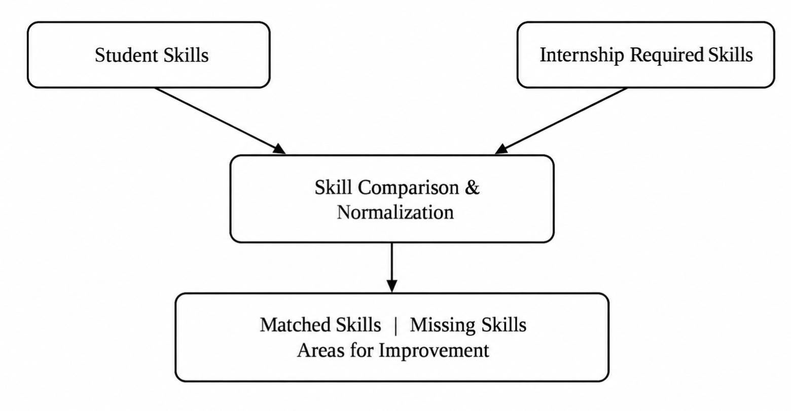
Skill-gap analysis compares the student's existing skills with the skills required by relevant internship opportunities. The comparison can identify matched skills, missing skills, and areas for improvement. The module is intended to provide actionable information about the requirements of a target opportunity. It does not automatically teach the missing skills unless a separate learning-resource module is implemented.

5.7 Modules
Module | Function
1. Student Profile Management | Collects and manages relevant student information required for recommendation.
2. Internship Data Management | Stores and manages structured internship information and associated requirements.
3. Data Preprocessing | Prepares textual and structured information for consistent comparison.
4. Recommendation Engine | Applies TF-IDF, cosine similarity, and weighted matching logic.
5. Skill Gap Analysis | Compares student skills with internship requirements and identifies missing or improvement-oriented skills.
6. Backend API | Provides Flask REST endpoints and coordinates application modules.
7. Database | Uses MySQL for persistent storage of system information.
8. Frontend | Uses React.js and Tailwind CSS for user interaction and presentation.

5.8 Flowchart
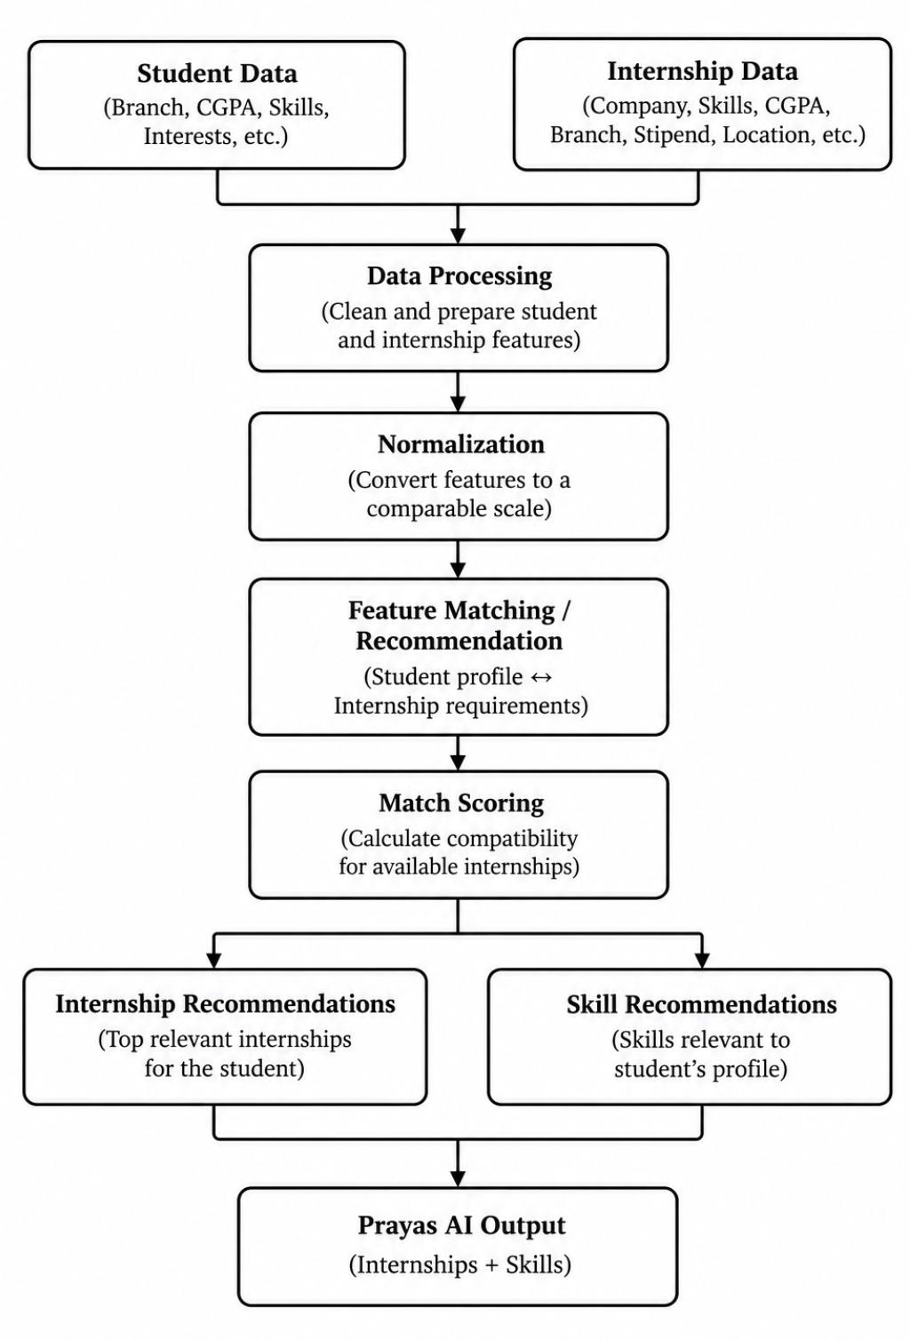
The flowchart summarizes the end-to-end recommendation process from student and internship data input to the final Prayas AI output. The process begins with student data such as branch, CGPA, skills, and interests, along with internship data including company, skills, CGPA requirements, branch, stipend, and location. The collected information is first passed through data processing, where the student and internship features are cleaned and prepared. The processed features are then normalized so that different attributes can be considered on a comparable scale.
After normalization, the system performs feature matching by comparing the student profile with the requirements of available internships. A match score is then calculated to determine the compatibility of the student with different internship opportunities. Based on the matching results, the system generates two types of recommendations: relevant internship recommendations and skill recommendations related to the student's profile. These results are finally combined and presented as the Prayas AI Output, containing relevant internships and associated skills.

6. Implementation & Results

6.1 Implementation
The project is being implemented as a web-based academic prototype. The backend is being developed in Python using Flask and Flask REST APIs. The MySQL database named prayasai_disha has been configured for development, and database connectivity has been tested in the development environment. The frontend is being developed using React.js and Tailwind CSS. The AI/ML module is being developed using Python, Pandas, and scikit-learn with TF-IDF, cosine similarity, and weighted recommendation logic.
The project repository contains the development work for the PrayasAI Disha application, including backend-related work and database integration. Team responsibilities are distributed across backend and coordination, database design, AI/ML integration, and frontend development. The implementation is iterative, so individual modules may reach different levels of completion during development.

6.2 Current Development Status
Component | Status | Description
Flask Backend | Implemented / under development | Backend environment and application structure are being developed; API modules remain subject to ongoing integration.
MySQL Database | Configured / tested | Development database prayasai_disha and database connectivity have been configured and tested.
React Frontend | Under development | Frontend structure and user-facing components are being developed.
Recommendation Engine | Under development | TF-IDF, cosine similarity, and weighted matching logic are being integrated.
Skill Gap Analysis | Under development | Skill comparison logic is being developed as a dedicated recommendation-support component.
Internship Data Acquisition | Under development | Validated data acquisition from the PM Internship Scheme domain remains subject to implementation and source/API verification.
Final Evaluation | Pending | Quantitative accuracy, precision, recall, F1, response-time, and user-study results have not been finalized.

6.3 Expected / Available Results
The intended functional result is a personalized set of internship opportunities that are compatible with the student's profile, together with a skill-gap view that identifies skills already matched and skills that may require improvement. The frontend is expected to present these outputs in an understandable format after the backend and recommendation components are fully integrated.
At the current synopsis stage, final quantitative evaluation results are not available. Accordingly, this document does not claim recommendation accuracy, precision, recall, F1-score, dataset size, number of users, number of internships, response time, deployment statistics, or recommendation success rate. Such values should be added only after the team completes reproducible testing and records the actual measurements.
The expected output of the system includes relevant internship recommendations based on the student's profile and the requirements of available opportunities. Along with the recommended internships, the system is expected to provide information about relevant skills and potential skill gaps. This allows the student to understand both the opportunities that match the current profile and the areas that may require further improvement.
Suggested screenshots for the final project report, once the corresponding modules are actually implemented, include: student profile form, internship listing/data view, recommendation results, skill-gap results, backend API response, and MySQL database structure. Screenshots should be inserted only for features that exist in the final build
The proposed results are intended to support students in making more informed decisions about internship opportunities by presenting relevant opportunities together with the skills associated with them. By combining recommendation results with skill-gap information, the system can provide a more complete view of the student's current profile and the requirements of potential internships. This approach is expected to make the internship discovery process more structured and help students identify areas for further skill development.
The proposed system can also provide a structured basis for future evaluation and improvement. Once the implementation is completed, the recommendation process can be tested using actual student and internship data to assess the relevance of generated recommendations and the usefulness of the identified skill gaps. The findings from such evaluation can then be used to refine the matching process and improve the overall functionality of the system.

7. SDG Goals Mapping
The United Nations Sustainable Development Goals provide a framework for relating technology projects to broader social and developmental objectives. The relationship below is based on the actual scope of PrayasAI Disha rather than on a generic list of SDGs.
SDG | Relevance to PrayasAI Disha | Nature of Contribution
SDG 4 – Quality Education | Primary | The system can help students understand internship requirements, identify relevant opportunities, and recognize skills that may need further development, supporting practical and career-oriented learning.
SDG 8 – Decent Work and Economic Growth | Primary | The project focuses on internship discovery and employability-related skill alignment, supporting students in navigating opportunities connected with professional development.
SDG 10 – Reduced Inequalities | Secondary / conditional | If designed and made accessible across student groups, personalized matching can help reduce information-access barriers. This relationship should be presented as a potential contribution rather than a proven impact.

The primary SDG alignment is with SDG 4 and SDG 8 because the system directly addresses learning-to-opportunity alignment and internship/employability support. SDG 10 is treated as a secondary and conditional connection because reduced inequality would depend on how the system is made accessible and how fairly opportunities are represented in the underlying data.
The proposed system contributes to these goals through its focus on improving access to relevant internship information and supporting students in identifying opportunities aligned with their academic and skill profiles. By presenting internship recommendations along with skill-gap information, the system can help students better understand available opportunities and the skills required to pursue them. The broader social impact, however, will depend on the accessibility, quality, and diversity of the data used by the system.
.

8. Conclusion and Future Scope

8.1 Conclusion
PrayasAI Disha proposes a web-based approach to personalized internship discovery and skill-gap analysis. The system addresses the practical difficulty of comparing a student's skills, academic background, interests, and preferences with the requirements of numerous internship opportunities. The proposed methodology combines NLP-based text representation through TF-IDF, cosine similarity for profile-to-opportunity comparison, and a weighted recommendation approach for incorporating multiple compatibility factors.
The system is designed as a layered application using React.js and Tailwind CSS on the frontend, Flask REST APIs and Python on the backend, and MySQL for persistent storage. A dedicated skill-gap analysis component complements the recommendation process by identifying skills that match internship requirements and skills that may require improvement. The project is currently under development, so the synopsis intentionally separates implemented development work from proposed functionality and does not claim unverified evaluation results or real-world deployment.

8.2 Future Scope
- Validated integration with live or regularly updated internship data sources, subject to availability, access permissions, and technical feasibility.
- Improved semantic matching using embeddings or advanced NLP techniques after obtaining an appropriate validated dataset.
- Feedback-based personalization that learns from student interactions and recommendation feedback.
- Learning-resource recommendations for identified skill gaps.
- Notification and reminder functionality for relevant internship opportunities.
- Analytics dashboards for students or academic internship coordinators.
- Improved scalability, security, authentication, and deployment architecture.
- Mobile-friendly enhancements and accessibility improvements.
- Comprehensive evaluation using a validated benchmark dataset and suitable recommendation metrics.

9. References

- Almalki, L., Al-Alsheikh, N., Bahareth, F., Abdullah, M., & Alsahafi, R. (2025). BERT-based job recommendation system using LinkedIn dataset. Journal of Information Systems Engineering and Management,10(8s),280–291.https://doi.org/10.52783/jisem.v10i8s.1026

- Alsaif, S. A., Sassi Hidri, M., Eleraky, H. A., Ferjani, I., & Amami, R. (2022). Learning-Based Matched Representation System for Job Recommendation. Computers, 11(11), 161.
https://doi.org/10.3390/computers11110161

- Poncio, F. P. (2024). Navigating techniques in job recommender systems on internship profile matching: A systematic review. Journal of Research in Innovative Teaching & Learning, 17(2),352–367.https://doi.org/10.1108/JRIT-01-2024-0016

- Pedregosa, F., Varoquaux, G., Gramfort, A., et al. (2011). Scikit-learn: Machine Learning in Python.JournalofMachineLearningResearch,12,2825–2830.
https://jmlr.org/papers/v12/pedregosa11a.html

- Meta Open Source. (n.d.). React Documentation. https://react.dev/

- Pallets Projects. (n.d.). FlaskDocumentation. https://flask.palletsprojects.com/

